Volunteers
Childcare | October 11, 2026
10:00 | Nursery- Miranda Bohler/ Liz Dillard
 | Toddler- Caroline Williams/ Lorin Melton
11:00 | Nursery- Available
 | Toddler- Susan Cauthen/ Greta Cureton
 | Elementary- Suzanne Lever/ Grace Kelso

Financials
September 27, 2026
Attendance AM | 61/4
Attendance PM | 24/?
General Fund | $2,701
Total GF contributions this month | $10,234
Missions Fund | $220
Memorial Fund | $660

Announcements
OCTOBER CALENDAR Here are the upcoming events on the church calendar. Please make sure to mark your calendars and sign up for these activities.
October 6- GIG 6:30PM
October 7, 14, and 28- WFN at 6:00PM
October 11- COMMUNION SUNDAY
October 11- Diaconate 12:15PM
October 13- Presbytery at Crossings Community Church
October 17- Men’s Prayer Breakfast 8:00AM
October 18- Pastor Appreciation Lunch 12:15PM
October 20- Session 7:00PM
October 21- FALL FESTIVAL 6:00PM
October 25- MISSIONS FUND SUNDAY

First ARP Church
Congregational Weekend
October 4, 2026
Welcome and Announcements Rev. Jonathan Williams
Call to Worship Psalm 103:1

¹Bless the Lord, O my soul, and all that is within me, bless his holy name!

Invocation
*Hymn Page 5
“All People That On Earth Do Dwell”
*Affirmation of Faith The Apostles’ Creed
I believe in God the Father Almighty, Maker of heaven and earth;
And in Jesus Christ His only Son our Lord;
Who was conceived by the Holy Ghost,
Born of the Virgin Mary, suffered under Pontius Pilate,
Was crucified, dead, and buried;
He descended into hell;
The third day He rose again from the dead;
He ascended into Heaven,
And sitteth on the right hand of God the Father Almighty;
From thence He shall come to judge the quick and the dead.
I believe in the Holy Ghost; the holy catholic** church;
The communion of saints; the forgiveness of sins;
The resurrection of the body; and the life everlasting. Amen.
*Hymn Page 6 “’O Worship the King”
Children’s Sermon
Pastoral Prayer
Sermon Text Jude 1:1-25
¹Jude, a servant of Jesus Christ and brother of James, To those who are called, beloved in God the Father and kept for Jesus Christ: ²May mercy, peace, and love be multiplied to you.
Judgment on False Teachers
³Beloved, although I was very eager to write to you about our common salvation, I found it necessary to write appealing to you to contend for the faith that was once for all delivered to the saints. ⁴For certain people have crept in unnoticed who long ago were designated for this condemnation, ungodly people, who pervert the grace of our God into sensuality and deny our only Master and Lord, Jesus Christ.
⁵Now I want to remind you, although you once fully knew it, that Jesus, who saved a people out of the land of Egypt, afterward destroyed those who did not believe. ⁶And the angels who did not stay within their own position of authority, but left their proper dwelling, he has kept in eternal chains under gloomy darkness until the judgment of the great day— ⁷just as Sodom and Gomorrah and the surrounding cities, which likewise indulged in sexual immorality and pursued unnatural desire, serve as an example by undergoing a punishment of eternal fire.
⁸Yet in like manner these people also, relying on their dreams, defile the flesh, reject authority, and blaspheme the glorious ones. ⁹But when the archangel Michael, contending with the devil, was disputing about the body of Moses, he did not presume to pronounce a blasphemous judgment, but said, “The Lord rebuke you.” ¹⁰But these people blaspheme all that they do not understand, and they are destroyed by all that they, like unreasoning animals, understand instinctively. ¹¹Woe to them! For they walked in the way of Cain and abandoned themselves for the sake of gain to Balaam’s error and perished in Korah’s rebellion. ¹²These are hidden reefs at your love feasts, as they feast with you without fear, shepherds feeding themselves; waterless clouds, swept along by winds; fruitless trees in late autumn, twice dead, uprooted; ¹³wild waves of the sea, casting up the foam of their own shame; wandering stars, for whom the gloom of utter darkness has been reserved forever.
¹⁴It was also about these that Enoch, the seventh from Adam, prophesied, saying, “Behold, the Lord comes with ten thousands of his holy ones, ¹⁵to execute judgment on all and to convict all the ungodly of all their deeds of ungodliness that they have committed in such an ungodly way, and of all the harsh things that ungodly sinners have spoken against him.” ¹⁶These are grumblers, malcontents, following their own sinful desires; they are loud-mouthed boasters, showing favoritism to gain advantage.

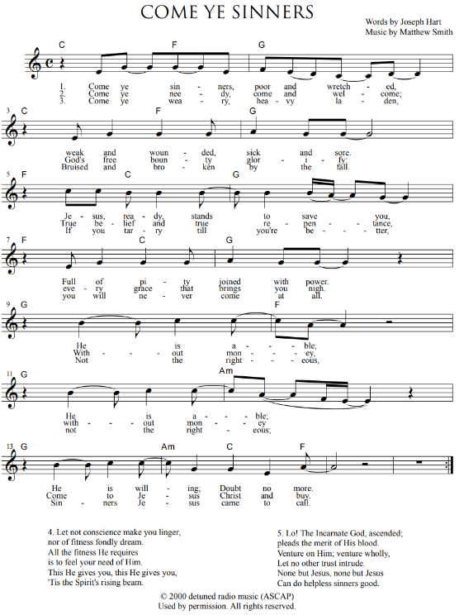

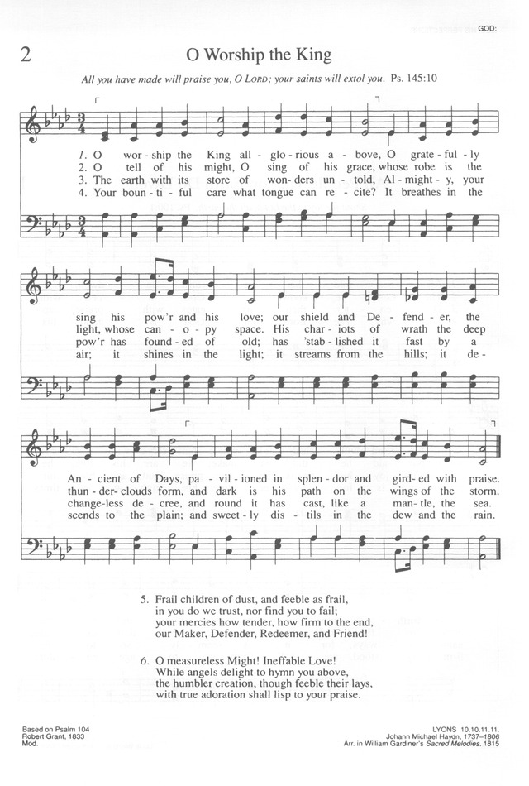

A Call to Persevere
¹⁷But you must remember, beloved, the predictions of the apostles of our Lord Jesus Christ. ¹⁸They said to you, “In the last time there will be scoffers, following their own ungodly passions.” ¹⁹It is these who cause divisions, worldly people, devoid of the Spirit. ²⁰But you, beloved, building yourselves up in your most holy faith and praying in the Holy Spirit, ²¹keep yourselves in the love of God, waiting for the mercy of our Lord Jesus Christ that leads to eternal life. ²²And have mercy on those who doubt; ²³save others by snatching them out of the fire; to others show mercy with fear, hating even the garment stained by the flesh.
Doxology
²⁴Now to him who is able to keep you from stumbling and to present you blameless before the presence of his glory with great joy, ²⁵to the only God, our Savior, through Jesus Christ our Lord, be glory, majesty, dominion, and authority, before all time and now and forever. Amen.
Sermon Title
“Persevere In Grace”
*Hymn of Response Page 7
“’Come Ye Sinners”
*Free Offer of the Gospel
*Benediction Numbers 6:24-26
The LORD bless you and keep you; the LORD lift His face to shine upon you and be gracious to you; the LORD lift His countenance upon you and give you peace.
Congregational Response
May the peace of God our heav’nly Father, and the grace of Christ the risen Son, And the fellowship of God the Spirit keep our hearts and minds within His love, And to Him be praise for His glorious reign. From the depths of earth to the heights of heav’n We declare the name of the Lamb once slain, Christ Eternal, the King of Kings.
“Benediction” / Stuart Townend and Keith Getty / © 2005 Thank You Music
CCLI License #399806

SERMON NOTES
Jude 1:17-25 “ Persevere In Grace”

